Havering and South Essex Orienteering Club

2025 Twilight Series

A series of app-based (MapRun), mixed format, low-key evening events

suitable for newcomers, improvers and more experienced runners
Date | Base Pub | Public Transport | Planner/ Organiser
10th September | Royal Oak, South Ockendon. RM15 6SD  w3w: look.stone.dads | Ockendon  (C2C) 0.3 miles from start | Seb Parris
24th September | The Railway, South Woodham Ferrers. CM3 5NG  w3w: loops.greed.handsets | South Woodham Ferrers  (Greater Anglia) 0.1 miles from start | David Float
8th October | Gardeners Arms, Brentwood. CM14 4AX  w3w: margin.gaps.silk | Brentwood  (Greater Anglia) 0.5 miles from start | Colin Jackson

Further details will be on https://www.orienteering-havoc.co.uk/ with flyers for each event.

Format: Paper maps, and timing via the MapRun app: either have a smartphone with you whilst you run, or load the MapRunG app onto a compatible Garmin watch. Details of how orienteering works with this app can be found on this webpage, with a userguide and links to the app. Using this app makes it easier to run the event on the day, and allows you to instantly see results and compare routes taken with other competitors.

Entry: Will be on https://racesignup.co.uk/ Enter in advance for each event.

Costs: Small cost per event to cover map printing, permissions, BOF levy and a donation to the MapRun app developers. £4 senior, £2 junior, additional £1 for non BOF members.

Timing: Starts 6.30pm-7.30pm, courses close 9pm

Maps and Courses: All events will use OpenOrienteeringMap, an example of which is shown on the right.  The controls you are looking for are shown by circles on the map. Control descriptions are provided.  There will be a Short and Long option at each event. | 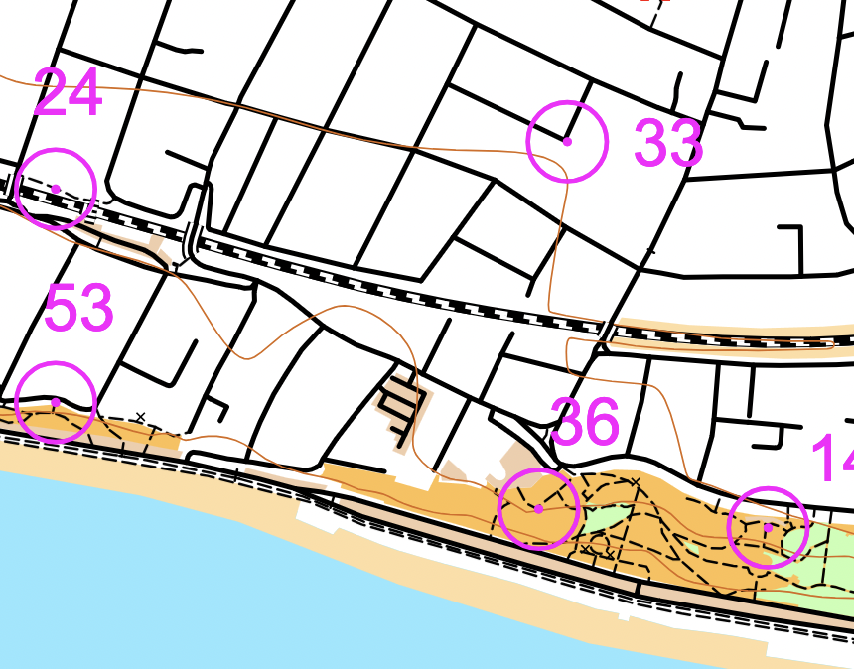
Each event will have a specific format. We will have a traditional score, a Snooker-O and a Spiral-O. There are two time limits available - runners on the Long course will have 60 mins, and those on the Short 40 mins, to score as many points as possible and return to the start/finish. Number of controls visited and route choice are up to the individual competitor.

Series league: Scores on the Short course are multiplied by 150% and included in one overall table with the Long course. All scores are handicapped based on age and sex.

Meeting point and Après-O: Meeting points in a pub with nearby start.

Series co-ordinator: Please contact streeto@orienteering-havoc.co.uk for further details or any queries.

You are responsible for your own safety and you take part in this event at your own risk. British Orienteering 3rd Party
insurance does not cover any non-member of a British Orienteering affiliated orienteering club at this event if that person has
taken part in three or more British Orienteering registered events.

