 Havering and South Essex Orienteering Club
Line/Spiral Hybrid
Wickford – Wed 7th Oct 2026
___________________________________________________________________________________________________________________________________

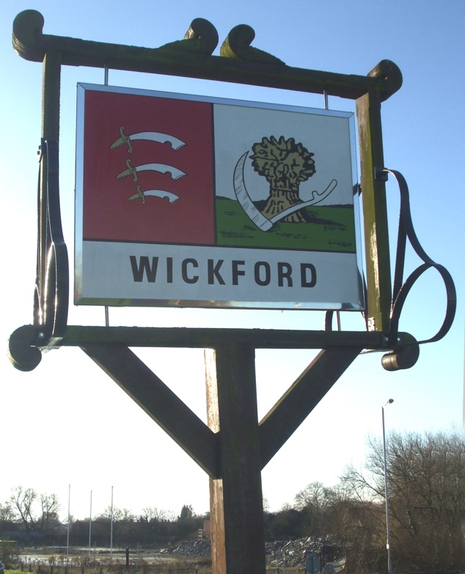 |  | 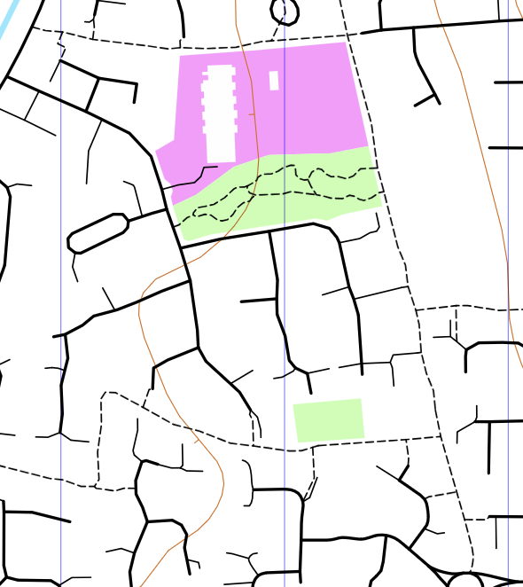
Event | Line/Spiral hybrid event in Wickford. Wickford was a settlement in the Domesday Book, and has a name based on the Saxon for “a sheep farm on a river crossing”. It’s developed a bit since then, and the courses will be mainly in an intricate part of the town, using footpaths and curved roads. This event is predominantly on street running, MapRun based, with controls located on fire hydrant signs and other street furniture.
Series | As well as a standalone event, this will be event 3 of the HAVOC Twilight series 2026  For the series, there will be three events, each with a specific scoring format. Each event will have two courses - Long and Short. Points will be awarded for each control visited (specific course rules apply on different events), and then adjusted using an age/gender handicap system. Bonus points for running on the night compared to Anytime. Full results will be emailed via RaceSignUp and published on the HAVOC website.
Location | The event starts at: The Duke pub  Address: 80 High St, Wickford SS12 9AT  What3Words location: //alone.finely.heads  Note that the finish is approx. 300m from the pub.  There is a small car park at the pub, or a larger public car park within 300m, free after 6pm, entrance at ///dice.vote.engine  The pub is approximately 0.5km from Wickford Train Station, which is served by Greater Anglia trains every 10-15 mins journey time 37 mins from London Liverpool Street. Return trains every half hour until 11.26pm.  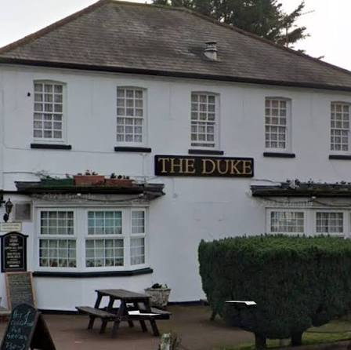
MapRun | We are going to run this event using the MapRun software. Therefore, please, if possible, use a smartphone (or Garmin watch) and ensure you have latest version of MapRun installed, and the course is downloaded to your phone/watch before you arrive.  As this series is using some scoring features of MapRun, competitive running is not possible with manual timing. You are still welcome to run, and your scores and time will be checked manually, but you will be listed as non-competitive in the results.  Note: All competitors will still receive a paper map - no need to squint at your phone to see the route!  Details of how to obtain a copy of the app and how it works can be found here.  There is also a HAVOC user guide here.  Download the course onto the app by clicking on ‘Select Event', in the app, and following the menu path UK > Essex  The courses are:  Wickford 2026 Twilight Long  Wickford 2026 Twilight Short  The course map will not be visible on your phone until you receive the PIN number at Registration on the night. (Note – you do not need the PIN number to run using a Garmin watch). There are no written answers required with MapRun and your result will be automatically downloaded when you finish. The full procedure will be explained at Registration.
Pre-Entry, Fees and Payment | £4 Seniors, £2 under 21 or students.  Pre-entry and pre-payment are required using racesignup.  Additional £1 payable if not a BOF member, to cover insurance costs. In order to avoid that surcharge, consider joining HAVOC – details here.
Times | Start times between 6:30pm and 7:30pm. Courses close at 9pm.
Courses | Two Line/Spiral courses – Long and Short  The aim of this course is to visit ALL the controls, in order, on the base line. This is purposefully shorter than normal, so hopefully you would be able to finish this within the time limit of 40 mins short/60 mins long. Each control on the line is worth 10 points.  As just doing the line would likely get you back to the finish well within the time limit, there are a series of optional spirals on some of the controls. Visiting controls on these spirals will gain you extra points, but may leave you further away from the next control on the line. Therefore you need to judge whether it is worth visiting them for extra points, or not. There are up to three additional controls available on each spiral, and you have to take them in order (but you don’t have to complete the full spiral).  Controls ending in 1 (the first additional control on each spiral) are worth 5 points  Controls ending in 2 (the second additional control on each spiral, only valid after the first one) are worth 10 points  Controls ending in 3 (the third additional control on each spiral, only valid after the second one) are worth 15 points  Scoring examples:  1, 2, 21, 22, 23, 3 would score 10+10+5+10+15+10=60  1, 2, 22, 23, 3 would only get you a score for 1,2, and 3, so 30 points, as 21 was not visited before 22.  1, 2, 21, 22, 3 would score 10+10+5+10+10=45  Penalties are assessed if a runner fails to get back to the finish within the time limit – 10 points per minute or part minute late back.  Highest score wins.  It is likely that MapRun scoring won’t be able to cope with that scoring system, so full results will be issued after the event.  Controls will be fire hydrants; will likely also use other street furniture. As you are using MapRun then you will not need to record answers on a control card. If a control fails to register, but you believe to be in the correct place, then run on, and we will check your GPS track after the event.
Facilities | Shelter and Toilets will be available at The Duke pub ahead of the event.  Newcomers welcome. Help and guidance available.
Safety | Participation is at your own risk. Under 16s must be accompanied by an adult. Bring clothing and footwear appropriate for the weather conditions. As with any street orienteering you are required to cross roads and you are asked to take due care and attention at all times. High visibility clothing is strongly recommended. There may be dog walkers, cyclists or residents on pavements and footpaths – be aware and give them priority. Some roads do not have pavements so take extra care. As this event will take place in the twilight/at night, a head torch or similar is recommended. Night falls quickly and will be full by 8.13pm.  All competitors must report in the pub they have finished by 9pm, even if they wish to retire, so that we can complete safety checks and ensure all competitors have returned safely.
Series Website | Details of the full series, including fixtures, results and Anytime maps and instructions can be found on the series webpage.
Post Event | Venue for refreshments:  Address:
Event Officials | Organiser – Dale Bennett  Series Coordinator – David Float Email: streeto@orienteering-havoc.co.uk Tel: 07801 216634
Further details | 

