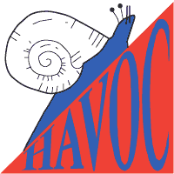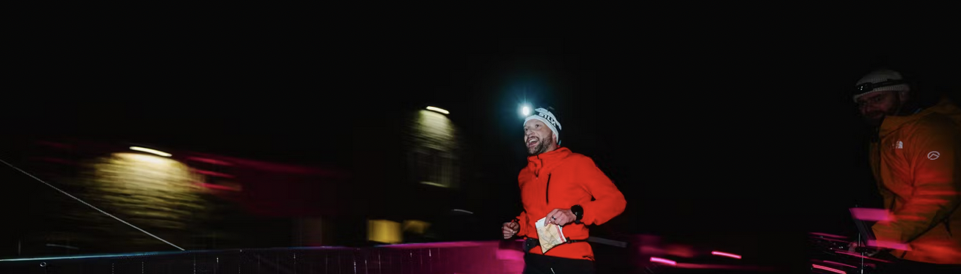

Essex Midweek Winter Series

Enter now at: www.racesignup.co.uk

1. 22nd Oct – Bocking; Braintree 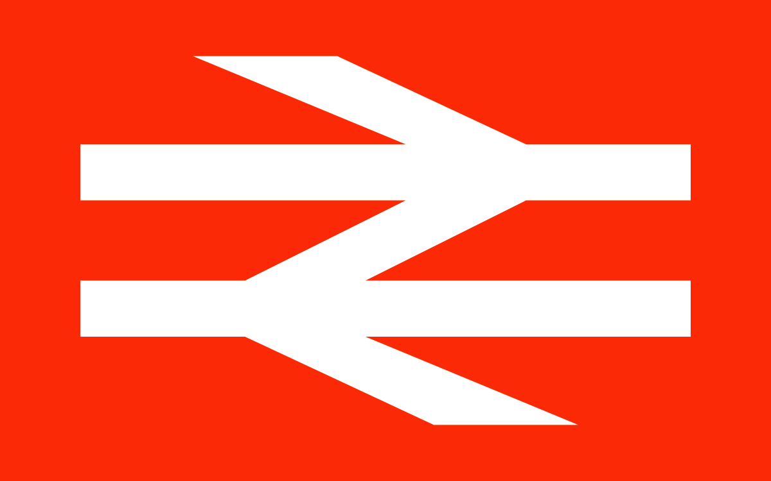

2. 5th Nov – Rayleigh 

7. 21st Jan – TBC

London Underground - Wikipedia

* *Suitable for all – Beginners, Improvers and Experienced Orienteers*
* *Walk, jog or run round some fun courses – Short (40 mins), Long (60 mins) score options*
* *All events close to public transport rail links*
* *Based in a pub for Post race refreshments*
* *Starts 6.30pm-7.30pm*
* *Entry Fee £4/5, or Golden Ticket*

Full details at:

www.orienteering-havoc.co.uk